PhotoZ LilJoe User Manual

8/26/2021
Payne Y. Chang
Updated for lilJoe - Meyer Jackson
張雲鵬

Table of Contents
Table of Contents i
1. Menu Bar 2
1.1 File 2
Open 2
Create Folder 2
Exit (ESC) 2
1.2 Preference 2
Save Preference 2
Load Preference 2
1.3 Save Left Window 3
1.4 Save Right Window 3
1.5 Save as Jpeg………………………………………………………………………..3
2. Array Window 3
3. Acquisition/Analysis Panel 4
3.1 Acquisition 4
Schedule Box 4
RLI Box 4
Stop 4
Live Feed …………………………………… ………………………………………4
Take RLI 4
Record 4
Save 4
3.2 Analysis 5
Go through Data 5
Save Selected 5
Load Selected 5
4. File Control Panel 5
4.1 File Name 5
4.2 Slice No 5
4.3 Location No 6
4.4 Record No 6
4.5 Trial No 6
5. Main Control Panel 6
5.1 Array Tab 6
Trace 6
RLI Value 6
Pixel No 7
Load Image 7
Digital Binning………………………………………………………………………...7
Background 7
Save Background Data 7
Y Scale 7
F.P. Y Scale 7
X Scale 7
X Shift 8
Nor2ArrayMax 8
Compare 8
Increase/Decrease 8
Actual/Percent 8
Ref. Record # 8
Final Record # 8
Average Records 8
# of Averaged Records 9
5.2 DSP (Digital Signal Processing) Tab 9
Main Tab 9
Correction 10
Filter 12
5.3 Baseline Tab 13
Baseline Correction Type 13
Polynomial Skip Window 13
Arbitrary Mode 13
5.4 Image Tab 14
X Position 14
Y Position 14
Width 14
Height 14
Output Image Format 14
Input Image Format 14
White Background 14
5.5 Color Tab 15
Color Scale 15
Control Mode 15
Bounds 15
Center 16
6. Right Window - Multipurpose 16
6.1 Trace Tab 16
Trace Window 16
Value 17
Mode 19
Point Line 19
Trace 19
Slope 19
Time Course 19
Saved Traces 19
Vm 20
Alpha 20
Display 20
Simulation 21
Save/Load 24
6.2 DAP Tab 25
TTL Output Controls 25
Acquisition Controls 25
Stimulator #1 26
Stimulator #2 26
Record Schedule 26
Gain 27
Trial Controls 27
6.3 Map/Movie 27
Mode 27
Map Types 27
Movie Types 28
Color Controls 28
Movie Controls 29
Appendix I: Settings Saved in A PRE File 31
Appendix II: The Structure of A ZDA File 33
Appendix III: Comments on CPP and H Files 35

A snapshot of the user interface.

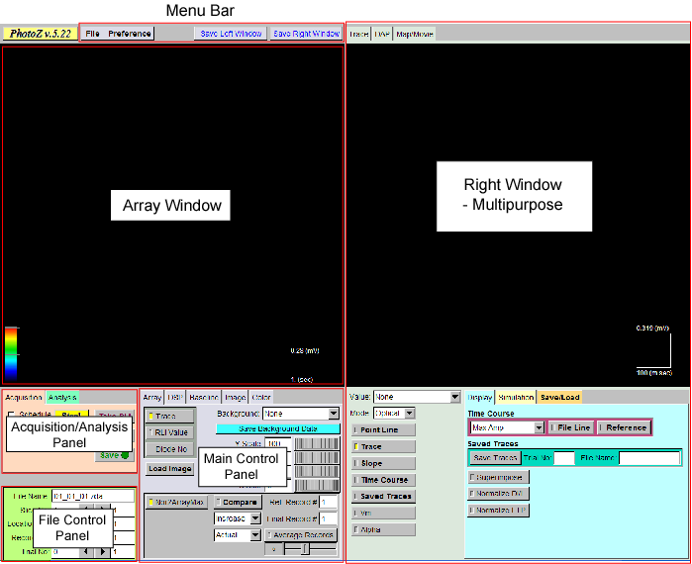

1. Menu Bar

1.1 File

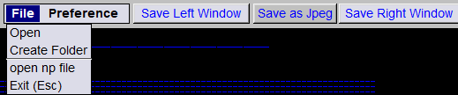
Open
Opens a data file. A window will show up, in which the user can select a data file to load.

Create Folder
Creates a folder to store data. It is recommended to create one folder for the data collected in one day.

Open np file
Opens a file created by Neuroplex.

Exit (ESC)
Exits the program, the same as click the “ESC” button.

1.2 Preference

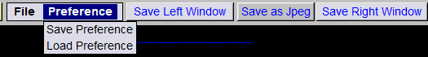
Save Preference
Saves most settings to a PRE file. Preference files contain stimulation and display parameters (Appendix I).

Load Preference
Loads most settings from a PRE file.

1.3 Save Left Window
Saves the left window to an image file. The user can change the image format at [Main Control Panel -> Image]. Must be in full screen

1.4 Save Right Window
Saves the right window to an image file. Must be in full screen
1.5 Save as Jpeg
Saves windows in Jpeg format. Must be in full screen

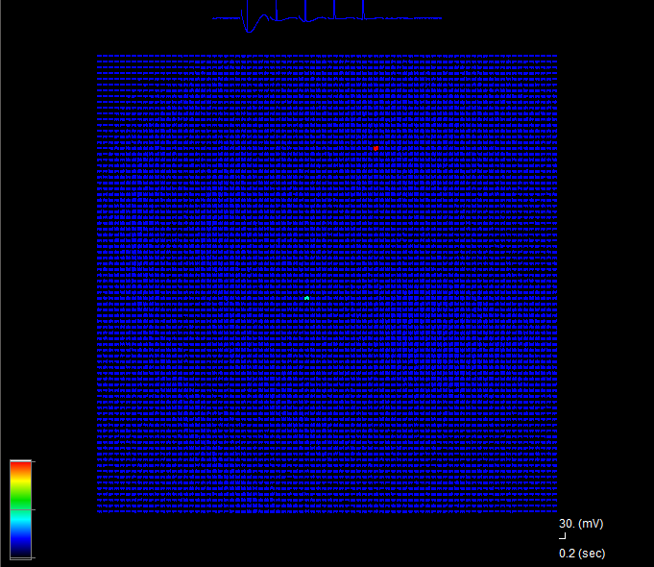
2. Array Window
With no binning there are 6400 traces representing optical signals from pixels and eight traces representing signals from analog inputs.
The color scale bar at the lower left corner is for some modes of backgrounds, which will be discussed later.
The scale bar at the lower right corner is for the optical signals.
To select/deselect one trace: [left-click the trace].
To unselect all traces: [right-click inside the window].
To ignore/include one trace for analysis: [shift + left-click the trace].

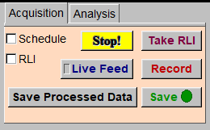
3. Acquisition/Analysis Panel

3.1 Acquisition

Schedule Box
When checked, the program keeps acquiring and saving data according to the settings in [DAP -> Record Schedule].

RLI Box
When selected, the program takes RLI (Resting Light Intensity) at the end of the recording.

Stop
Stops recording.

Take RLI
Measures resting light intensities. Reset pulse of 100 msec.

Live Feed
Produces a live real-time image of the camera in the array window. Useful for focusing and positioning.

Record
Acquires one record or starts a scheduled recording.

Save
Saves data to a ZDA file (The structure of a ZDA file is in Appendix II). When data have changed, the label turns red.

Save Processed Data
Not implemented.

3.2 Analysis

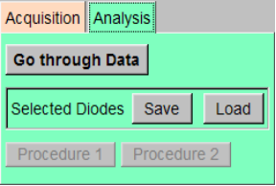Go through Data
Processes and analyzes all records for current Slice No and Location No. The settings of signal processing and analysis are the same as current settings. This analysis takes about a minute or two to finish.

Save Selected
Saves the selection of Pixels to a SEL file (the pixel numbers of selected pixels are saved).

Load Selected
Pixels are selected according to one SEL file.

4. File Control Panel

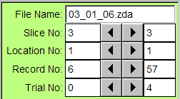
4.1 File Name
The name of the data file currently opened.

4.2 Slice No
The left number is the current slice number. The right number is the maximum slice number in the current folder. Clicking the left triangle (<) reduces the slice number. Clicking the right triangle (>) increases the slice number. NOTICE: The user can also key in a number in the current slice No box directly, but it does not go into effect until the user press the Enter key. This is also true for other input boxes.

4.3 Location No
The left number is the current location number. The right number is the maximum location number in this slice.

4.4 Record No
The left number is the current record number. The right number is the maximum record number in the current location.

4.5 Trial No
The left number is the current trial number. “0” represents the average of all trials in the record. The right number is the maximum trial number in the current record.

5. Main Control Panel

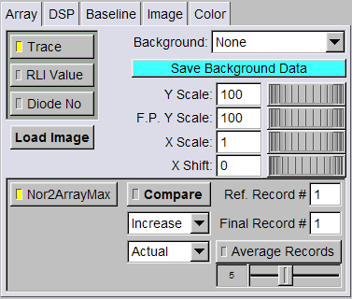
5.1 Array Tab
Controls the display in the array window.

Trace
When checked, the array window displays traces.

RLI Value
When checked, RLI value of each Pixel is displayed.

Pixel No
When checked, pixel number is displayed. When no binning it is too crowded but numbers are easy to see with Digital Binning of 4 or more.

Load Image
Loads an image file to display as the background. The image format is set in [Image -> Input Image Format].

Digital Binning
Binning of traces in the array window. 1 = 80x80, 2=40x40, etc

Background
The user can select either one of the following modes as the background in the array window.
None/Image/RLI/Maximum Amplitudes/Spike Amplitudes/Latency to a certain percent of Maximum Amplitude/Latency to Maximum Amplitude/EPSP Latency/Maximum Amplitude divided by Standard Deviation of baseline (SNR).
For the latency to a certain percent of Maximum Amplitude, the percentage setting is in [DSP -> Main -> Latency Measure Settings].

Save Background Data
Saves background information to a DAT file (e.g. maximum amplitudes for each pixel).

Y Scale
Controls the Y-axis scale of optical signals.

F.P. Y Scale
Controls the Y-axis scale of analog input signals (e.g. field potential).

X Scale
Controls the X-axis scale of all traces in the array window.

X Shift
Controls the shift in the X-axis for all traces.

Nor2ArrayMax
When checked, the color in the background of the array window is normalized to the array maximum.

Reset Camera
Reset camera. May solve a problem and easier than restarting program,

Save Latest LiveFeed image
Saves RLI image (not tested).

Compare
When checked, the data in Ref. Record and Final Record (described below) are subtracted and the difference is displayed, according to settings described below.

Increase/Decrease
Displays increase or decrease in data when Compare is checked.

Actual/Percent
Displays actual changes or percent changes.

Ref. Record #
The reference record number. Any record number can be selected. Usually, this is the record number just before the tetanic stimulation.

Final Record #
A record number which the user want to compare with the reference record.

Average Records
When checked, a number of records (described below) are averaged and displayed in the background in the array window and in the Map/Movie window. This function is available for maximum amplitude only.

# of Averaged Records
Slider sets the number of records to be averaged if “Average Records” is checked. For example, if the current record number is 17 and the number of averaged records is 5, the average of maximum amplitudes from record 13 to 17 is displayed. If “Compare” is checked and the Ref. Record # is 20 and the Final Record # is 40, the averages of maximum amplitudes from record 16 to 20 and 36 to 40 are compared and the differences are displayed.

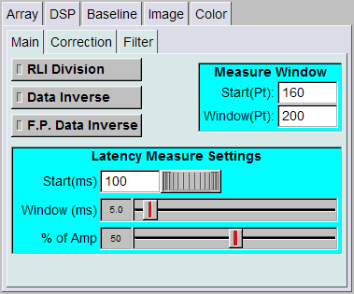
5.2 DSP (Digital Signal Processing) Tab

Main Tab

RLI Division
When checked, the optical signals are divided by RLI.

Data Inverse
When checked, the optical signals are inverted.

F.P. Data Inverse
When checked, the analog signals (usually field potential) are inverted.

Measure Window
The time window in each trace to analyze the data, for example, to measure the maximum amplitude and the latency.

Latency Measure Settings
Sets how the latency is measured and displayed in the array window. “Start” indicates the start time in msec. “Width” indicates the longest latency to be displayed. Shorter latencies are shown in red and longer latencies are shown in dark blue. Latencies shorter than “Start” are shown in white, while latencies longer than “Start” + “Width” are shown in black.
“% of Amp” sets the percent of maximum amplitude, to which the latency is measured.

Correction

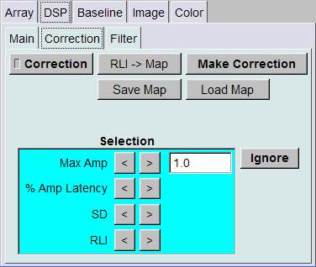
Correction
When checked, the data is corrected by an internal map (Raw data * the value in the map). The initial values in the map are ones. This is another way to do RLI division and perform a manual correction of signal amplitude from bad pixels.

RLI->Map
Transfers the inverse of RLI to the map. This results in RLI division if “Correction” is selected.

Make Correction
A few pixels do not cohere with other pixels (The amplitude is much larger or smaller than the amplitudes of signals in surrounding pixels). In this case, we can ignore this pixel or correct the amplitude manually. To manually correct the amplitude, first clear all selected pixels. Second, select the pixel the user want to correct. Third, select a reference pixel, which should have similar amplitude. Last, click the “Make Correction” button. The program scales the first trace in the trace window according to the second selected trace.

Save Map
Saves the current map to a MAP file.

Load Map
Loads a map to the internal map from a MAP file.

Selection
Provides four methods to select pixels, which can be ignored during analysis. The user can key in the value of a threshold in the text box. This feature enables the user to clean up a map by removing pixels with less information.

Max Amp
When the “<” button is clicked, pixels with maximum amplitudes less than the threshold are selected. When the “>” button is clicked, pixels with maximum amplitudes greater than the threshold are selected.

% Amp Latency
When the “<” button is clicked, pixels with latencies to a certain percent of maximum amplitude (see Main Control Panel -> DSP Tab -> Main Tab) shorter than the threshold are selected. When the “>” button is clicked, pixels with latencies to a certain percent of maximum amplitude longer than the threshold are selected.

SD
When the “<” button is clicked, pixels with a standard deviation less than the threshold are selected. When the “>” button is clicked, pixels with a standard deviation greater than the threshold are selected.

RLI
When the “<” button is clicked, pixels with resting light intensity less than the threshold are selected. When the “>” button is clicked, pixels with resting light intensity greater than the threshold are selected.

Ignore
When clicked, pixels selected by the above criteria are ignored.

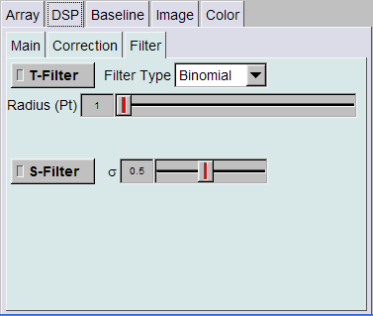
Filter

T-Filter
When checked, temporal filter is used during signal processing.

Filter Type
The user can choose either binomial filter or moving average filter for the temporal filter. Binomial4, 6 and 8 are faster and may be advantageous for real time use during data acquisition.

Radius
Sets the time-scale of the temporal filter. The width of the temporal filter is (2 * Radius + 1).

S-Filter
When checked, a Gaussian spatial filter is used during signal processing.

 
Sets the spatial constant for the Gaussian spatial filter. The unit is the pixel diameter.

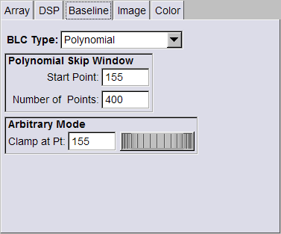
5.3 Baseline Tab

Baseline Correction Type
Sets the type of baseline correction. There are five types (None/Start Point/Start and End Points/Polynomial/Arbitrary).

Start Point
The start point of the trace is clamped to zero.

Start and End Points
The start and the end points are clamped to zero according to a line connecting the start and end points of the raw data.

Polynomial
The baseline of the signal is corrected according to a third-degree polynomial function. The polynomial function is created by fitting the raw data, excluding a window set in the Skip Window box. The settings of the excluding window are described below. This allows the user to exclude the evoked response from the baseline fit.

Polynomial Skip Window
Sets the time window, which is excluded in the polynomial fitting. The “Start Point” specifies the start point of the temporal window in points. The “Number of Points” indicates the number of points in the skip window.

Arbitrary Mode
Sets the point to be clamped to zero in the arbitrary mode.

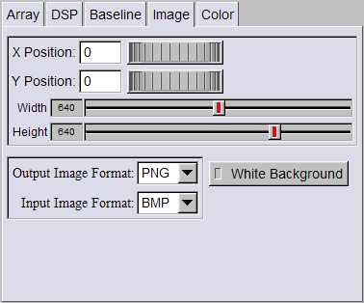
5.4 Image Tab
Controls the position and size of the CCD image in the background of the array window when an image is selected as background. It also sets the image format for input and output. Position controls were more important for the old photodiode array setup.

X Position
Sets the x-coordinate of the top-left corner of the image (in pixels).

Y Position
Sets the y-coordinate of the top-left corner of the image (in pixels).

Width
Sets the width of the image (in pixels).

Height
Sets the height of the image (in pixels).

Output Image Format
Sets the output image format (PNG, BMP, JPEG, TIFF).

Input Image Format
Sets the input image format (PNG, BMP, JPEG, TIFF).

White Background
When checked, it switches the background color from black to white.

5.5 Color Tab
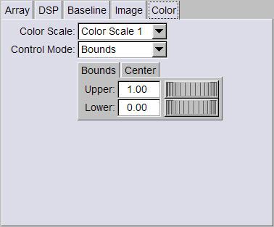
Controls the color scale bar in the array window.

Color Scale
There are four types of color scale bar (Color Scale 1/Color Scale 2/Blue to Red/Gray Scale).
Color Scale 1 | Color Scale 2 | Blue to Red | Gray Scale  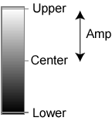

Control Mode
Sets how the color scale bar is adjusted. There are two types (Bounds/Center-Amp).

Bounds

Upper
Sets the upper boundary of the color scale bar.

Lower
Sets the lower boundary of the color scale bar.

Center

Amp
Sets the amplitude range of the color scale bar.

Center
Sets the center of the range for the color scale bar. The range of the color scale bar is from (Center – Amp) to (Center + Amp).

6. Right Window - Multipurpose

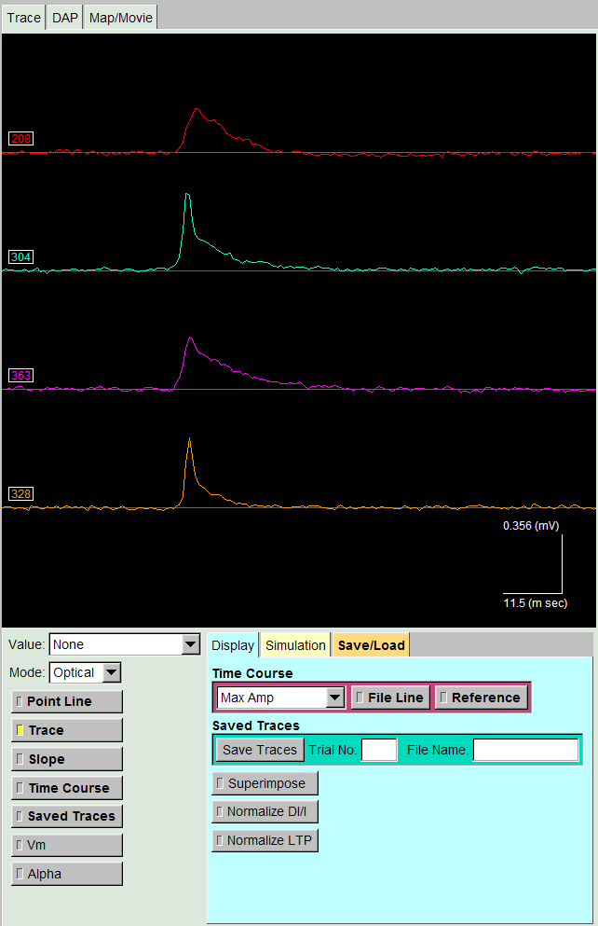
6.1 Trace Tab

Trace Window
Displays traces selected in the array window.

Control
[left click and drag] controls the scales in x and y axes according to the last trace.
[right click and drag] moves traces in the trace window.
[shift + right click] resets the scales in x and y axes.
[middle click] sets the x coordinate of the point line (gray).

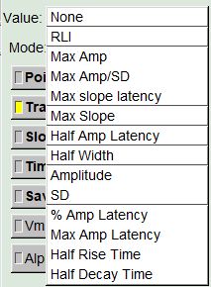
Value
Selects the quantity to be displayed in the trace window. The quantities are described below.

None
No value is displayed.

RLI
Resting light intensity.

Max Amp
Maximum amplitude.

Max Amp/SD
Maximum amplitude divided by standard deviation. Signal-to-noise ratio.

Max Slope
Maximum slope within the analysis window.

Half Amp Latency
Time from acquisition start to point of half maximum amplitude.

Half Width
Half width

Amplitude
The amplitude at the point line (the gray line in the trace window).

SD
The standard deviation of the initial baseline (before the start point of the analysis window).

% Amp Latency
The latency to a certain percent of the maximum amplitude [Main Control Panel -> DSP Tab -> Main Tab].

Max Amp Latency
The latency to the maximum amplitude

Half Rise Time
Time from half max amplitude before peak to time at peak

Half Decay Time
Time from peak to half max amplitude after peak.

Mode
Set what signals are controlled by dragging the mouse in the trace window.

Optical
The mouse controls the x-scale of optical signals and the y-scale of both optical signals and time course plot.

Field
The mouse controls the scales of analog input signals.

LTP
The mouse controls the x-scale of time course and the y-scale of both the time course and optical signals.

Point Line
When checked, the vertical point line (gray) is displayed (x-coordinate set by center mouse button).

Trace
When checked, traces are displayed.

Slope
When checked, the derivatives are displayed.

Time Course
When checked, time courses are displayed.

Saved Traces
When checked, saved traces are displayed (gray traces). Does not work with ROIs

Vm
When checked, calculated EPSP is displayed (green). Not functional.

Alpha
When checked, the alpha function used to simulate the EPSP is displayed (gray). The function is used to calculate Gsyn (see Chapter two of Payne’s thesis). Not functional.

Display
Controls the display in the trace window.

Time Course
Controls the display of the time courses. The trace window can display five types of time courses (RLI/Amplitude/Max Amp/% Amp Latency/Max Amp Latency). Amplitude is the amplitude at the point line.
When “File Line” is checked, a green vertical line indicating the position of current record is displayed.
When “Reference” is checked, a blue horizontal line indicating the value of the reference record is displayed.

Saved Traces
Saves the traces of current trial to an internal memory. When “Saved Traces” is checked, the saved traces are displayed (white). “Trial No” represents the trial number of saved traces. “File Name” indicates the file name of saved traces.

Superimpose
When checked, traces are superimposed.

Normalize DI/I
Normalizes ΔI/I so that the amplitudes of traces are set to one. This function is useful when the user want to examine the latencies of responses at different locations.

Normalize LTP
Normalizes the reference value prior to TBS to one (the reference record).

Simulation Not Functional
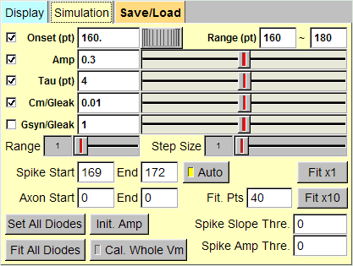
Controls the simulation of the EPSP component.

Onset
Sets the start point of the simulated EPSP. When the box is checked, the program varies the onset point to minimize the sum-of-square error. When the box is cleared, the onset point is fixed. The boxes before the other four variables have a similar function.

Range
Constrains the range of the onset point for fitting.

Amp
Sets the amplitude of the simulated EPSP.

Tau
Sets the time constant in the alpha function.

Cm/Gleak
Sets the ratio of Cm to Gleak (membrane capacitance to leak conductance).

Gsyn/Gleak
Sets the ratio of Gsyn to Gleak (synaptic conductance to leak conductance).

Range
Sets the range that the program searches for a set of parameters during fitting. Taking Amp for example, when the range is set to one, the program calculates the error at the current setting, moves the slider to left by one step and calculates the error, then, moves the slider to right by one step and calculates the error, and last, picks the one with the minimum error. When the range is large, the time of computation is longer. When the range is small, the fitting might get stuck in a local minimum that is not a global minimum.

Step Size
Sets the step size of parameter variation during fitting. When the step size is large, the program reaches the minimum faster, but the precision might not be as good. When the step size is small, the program needs more time to reach the minimum, but the precision is better.

Spike Start/End/Auto
Specifies the start and end points of the spike component. This period is excluded in the fitting.
When “Auto” is checked, the program sets the spike period automatically. The period is defined as the time from the time point when the slope is 50% of the maximum slope to the time point when the slope is 50% of the minimum slope.

Axon Start/End
Specifies the start and end points of signals from presynaptic afferents. This window is excluded in the fitting.

Fit Pts
Specifies how many points are used for fitting after the onset point.

Fit x1
One iteration.

Fit x10
10 iterations.

Set All Pixels
Sets the variables of all pixels to the current set of parameters.

Init. Amp
Initializes the amplitude of the EPSP according to the maximum amplitude of each pixel.

Fit All Pixels
Fits the data from all pixels until the minimum square error is reached. This process might take a long time to finish.

Cal. Whole Vm
When checked, the program simulates the EPSP to the end of the trace, which takes a longer time to fit.

Spike Slope Thre.
Spike maximum slope threshold, used for automatic spike detection. The maximum slope must be greater than this value to be considered containing a spike. Without a spike, the spike period is not excluded in the fitting.

Spike Amp Thre.
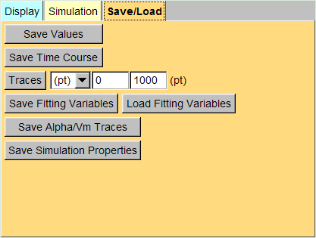
Spike maximum amplitude threshold, used for automatic spike detection. The maximum amplitude must be greater than this value to be considered containing a spike.

Save/Load

Save Values
Saves values displayed in the trace window to a DAT file.

Save Time Course
Saves displayed time courses to a DAT file.

Traces
Saves traces in the trace window to a DAT file. The user can switch the unit between points (pt) and time (ms). The following two boxes specify the start and end points.

Save Fitting Variables
Saves fitting variables of all pixels to a FIT file.

Load Fitting Variables
Loads fitting variables from a FIT file for all pixels.

Save Alpha/Vm Traces
Saves alpha and Vm traces to a DAT file.

Save Simulation Properties
The values of variables for the current simulation are saved to a DAT file.
Simulation

ROI
- New region
When active all selected traces are averaged and the average presented in the trace window. Shift-left click selects a 9 pixel square around the clicked pixel. To complete this ROI click New Region. To start a new ROI click New Region again.
- Save ROIs
Saves your complete set of ROIs to a text file.
- Load ROIs
Loads a set of ROIs previously saved.
- Current Regions and Regions Not functional

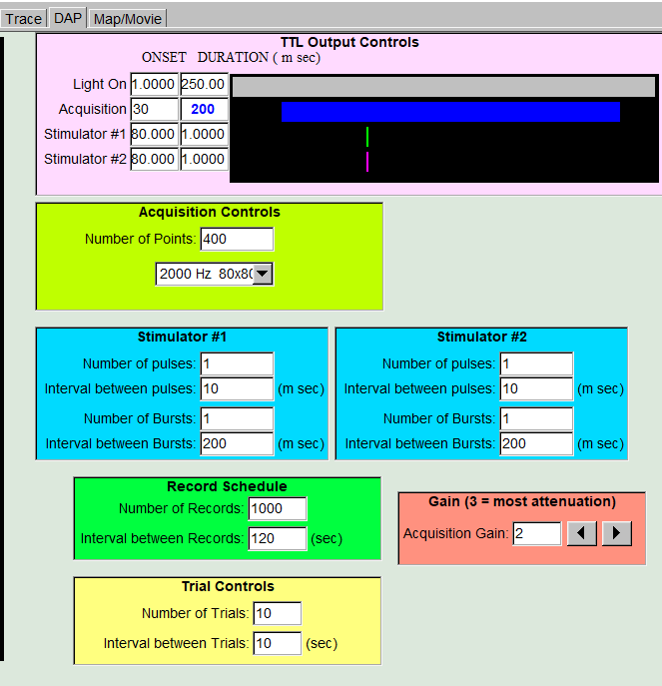
6.2 DAP Tab
Controls data acquisition, stimulation, recording settings.

TTL Output Controls
Sets the time for light on, onset of acquisition, onset and duration of digital outputs (always > 1 msec). Durations are displayed with colored bars. Duration of acquisition is not accessible in this window but is set in Acquisition Controls.

Acquisition Controls
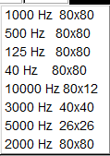
“Number of Points” specifies the number of points in each trace.
Box below specifies acquisition configuration to be used by the camera. Choices are shown to the right. Selections have varied acquisition rates and resolution. 2000 Hz 80x80 is most commonly used.

Stimulator #1
Controls the digital output for simulator #1 (e.g. single pulse or theta burst stimulation).
“Number of pulses” specifies the number of pulses in a burst.
“Interval between pulses” specifies the interval between two pulses within a burst.
“Number of Bursts” specifies the number of bursts.
“Interval between Bursts” specifies the interval between two bursts.

Stimulator #2
Controls the digital output for stimulator #2. The settings are the same as “Stimulator #1”.

Record Schedule
Sets up automated data acquisition according to a schedule.
“Number of Records” specifies the number of records. When “Schedule” is checked in the “Acquisition” tab, the program stops data acquisition automatically when the number of records is reached.
“Interval between Records” specifies the interval between two consecutive records (in seconds).

Gain
“Acquisition Gain” specifies the gain of the camera. Options are 0-3. The general rule is use highest gain that does not saturate the camera.

Trial Controls
“Number of Trials” specifies the number of trials in one record. Trials are typically averaged in a displayed record.
“Interval between Trials” specifies the interval between two consecutive trials.

6.3 Map/Movie

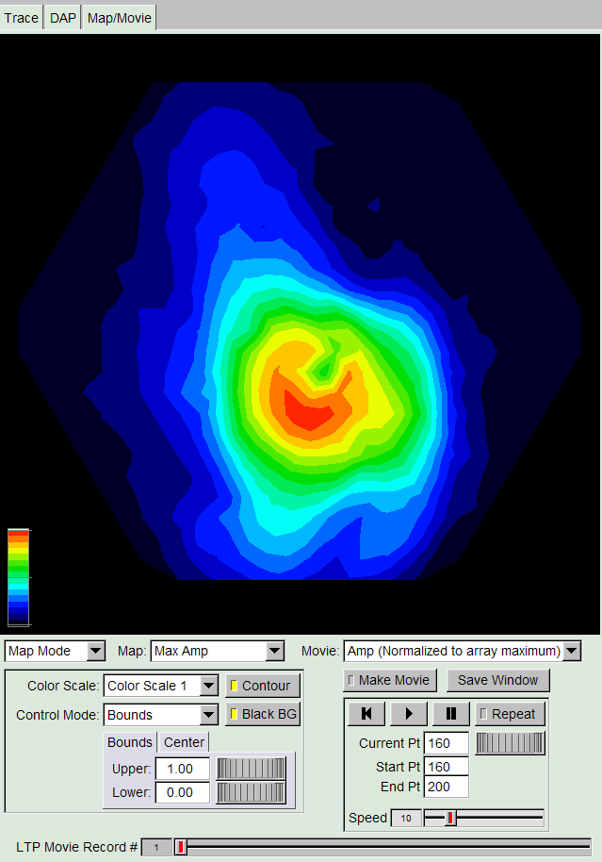
Mode
Specifies the display mode of the window. There are two modes (Map and Movie).

Map Types
Specifies the property to be displayed as a map.

RLI
Displays resting light intensity.

Max Amp
Displays maximum amplitudes.

Spike Amp
Displays the amplitudes of spikes. Fitting for all pixels needs to be completed in order to display correctly [Right Window -> Trace Tab -> Simulation Tab -> Fit All Pixels].

% Amp Latency
Displays the latencies to a specified percent of maximum amplitudes [Main Control Panel -> DSP Tab -> Main Tab -> Latency Measure Settings].

Max Amp Latency
Displays the latencies to the maximum amplitudes.

Movie Types

Amp (Normalized to array maximum)
Play a movie representing amplitudes normalized to the array maximum.

Amp (Normalized to pixel maximum)
Play a movie representing amplitudes normalized to the maximum amplitude of each pixel. This type of movie is useful for the analysis of activity propagation.

Color Controls
Controls the color scale bar in the bottom left corner. There are four types of color scale bars (Color Scale 1/Color Scale 2/Blue to Red/Gray Scale). The user can select the control mode from one of the two modes (Bounds/Center – Amp). In “Bounds” mode, the upper and lower bounds are controlled in the “Bounds” tab below. In “Center – Amp” mode, the center and the amplitude of the scale are controlled in the “Center” tab below.

Contour
When checked, the spectrum of the color is not continuous. Therefore, it can reveal the contours of equal values. When the box is cleared, the spectrum of the color in the scale is continuous.

Black BG
When checked, the background is black. When cleared, the background is white.

Movie Controls

|<
Rewind to the start point.

>
Play the movie.

||
Pause.

Repeat
When checked, the movie keeps playing.

Current Pt
Control and indicate the current point.

Start Pt
Specify the start point of the movie.

End Pt
Specify the end point of the movie.

Make Movie
When checked, the program creates a series of JPEG figures, which can be used to generate a movie.

Speed
Specify the speed of the movie.

Appendix I: Settings Saved in A PRE File
The codes for preference control are in “MainControllerFileController.cpp”.

//
2629112 (Identification number)
Version

Schedule Flag

// Image
The X-coordinate of CCD images
The Y-coordinate of CCD images
The width of CCD images
The height of CCD images

// DAP (The unit is ms.)
The start of reset
The duration of reset

The start of the shutter
The duration of the shutter

The start of data acquisition

The start of stimulator #1
The duration of stimulator #1 (usually 1 ms. this is just a trigger signal. The real duration of a stimulus is controller by the signal generator.)

The start of stimulator #2
The duration of stimulator #2 (usually 1 ms)

The number of points in a trace
The interval between two points in a trace (sampling interval)

The number of pulses in one burst for stimulator #1
The interval between two pulses for stimulator #1

The number of bursts for stimulator #1
The interval between two bursts for stimulator #1

The number of pulses in one burst for stimulator #2
The interval between two pulses for stimulator #2

The number of bursts for stimulator #2
The interval between two bursts for stimulator #2

// Record
The number of records
The interval between records (in seconds)

// Trial
The number of trials
The interval between trials

// Gain
The gain for data acquisition
The gain for RLI

// Examination window
The start of the examination window (in points)
The width of the window (in points)

// Baseline skip window for the polynomial fitting
The start of the skip window (in points)
The width of the skip window (in points)

Appendix II: The Structure of A ZDA File
The codes for the structure of a ZDA file are in “FileController.cpp”. Note that the data are saved in binary format, which can not be viewed by a regular text editor.

Version
Slice Number
Location Number
Record Number
Number of Trials
Interval between Trials
Acquisition Gain
RLI Gain
Number of Points per Trace
Current Time
Reset Onset
Reset Duration
Shutter Onset
Shutter Duration
Stimulation Onset
Stimulation Duration
Acquisition Onset
Interval between Samples
Resting Light Intensity
Raw Data

Raw Data:
Channel 1: First point, second point, ..., the last point
Channel 2: First point, second point, ..., the last point
...
Channel 472: First point, second point, ..., the last point

Appendix III: Comments on CPP and H Files
Chapter two of Payne’s thesis also contains some descriptions and comments.

ArrayWindow
ArrayWindow: Handles the events, display, and pixels in the array window.
Pixel: Handles the events and display inside one pixel in the array window.
Image: Controls and manipulates the CCD image.

TraceWindow
TraceWindow: Handles the events and the display in the trace window. It also controls the simulation of EPSP.

ColorWindow
ColorWindow: Controls the display in the Map/Movie window.
ColorWindowMovie: Controls the playback of a movie in the Map/Movie window.

MainController
Main: Starts the program.
MainController: Handles general interactions between objects.
MainControllerAcqui: Handles interactions between objects involved in data acquisition.
MainControllerArrayWindow: Handles interactions between Main Controller and Array Window.
MainControllerDAP: Handles interactions between Main Controller and DAP controller.
MainControllerFileController: Handles interactions between Main Controller and File Controller.
MainControllerLtp: Handles interactions between objects involved in the analysis of LTP.
MainControllerSignalProcessing: Handles interactions between Main Controller and Signal Processor.
MainControllerTraceWindow: Handles interactions between Main Controller and Trace Window.

Data
Data: Manipulates, processes and analyzes the data from one pixel.
DataArray: Manages all Data objects (472 objects).

Dap
DapChannel: Controls one digital output channel.
DapController: Manages all (8) DapChannel objects.
DapWndow: Controls the window displaying the timing of each output channel and the acquisition period.

Color
Color: Controls the color in Array Window, Trace Window and Map/Movie Window.

WindowExporter
WindowExporter: Controls the saving of Array Window and Right Window.

UserInterface
UserInterface: Controls the graphic user interface. The file is created by “IU Editor.exe”.
UserInterfaceMethods: Contains codes for the initiation and display of GUI.

SignalProcessor
Filter: Controls the temporal and the spatial filters.
PolynomialFitting: Controls the third order polynomial fitting of the base line correction.
SignalProcessor: Controls general signal processing.

RecControl
RecControl: Controls the settings and schedule of recording.

FileController
FileController: Controls data input and output.

DAPIO32.H: A header file provided by MicroStar Lab, which is required for DAP control.
Definitions.h: Contains some general definitions required in several classes.
Text.cpp: Controls the transfer from a number to a text.
DAPIO32.LIB: This library file is provided by MicroStar Lab, which is required for DAP control.
ExtermalDependencies: Other header and library files included by the C++ compiler.

